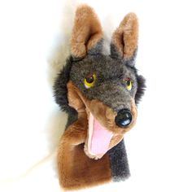
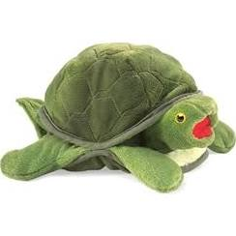
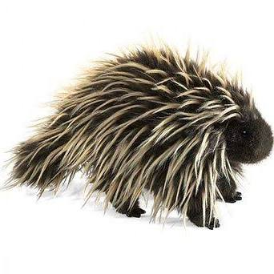
EGRESSIONS
A Puppet Play
June 11, 2017
1st Presbyterian Church
Pittsford, New York
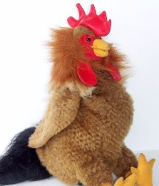
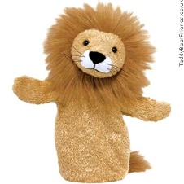
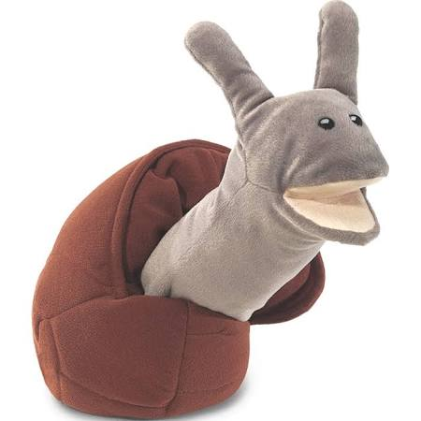
Characters:
Tom (the Turtle)
Sam (the Snail)
Penelope (the Porcupine)
Randolph (the Rooster)
Winifred (the Wolf)
Cupcake (the Lion)

TOM: (singing) O Give me a home, where the turtles all roam and the deer and antelope play, where seldom is heard, a discouraging word, for what can an antelope say? Home! Home by the pond – Oh, high Sam! I almost didn’t see you as I was streaking by.

SAM: Yes, I just don’t seem to be able to move faster than a snail’s pace. I wish I could speed walk, but it is hard when you only have one foot. You’ve got four feet, Tom. You’re lucky.

TOM: It’s nice to see you out of your shell, Sam.

SAM: You, too, Tom. By, the way did you see Randolph this morning?

TOM: You mean Randolph the rooster?

SAM: Yes, him!

TOM: I think I saw him trying to cross the road. Now, I ask you, why would a chicken try and cross a road? We turtles have better sense. If we are going to try and cross a road, we do it at night when there are fewer cars.

SAM: I don’t know, but we snails try to stay away from roads. According to Sir Isaac Newton, chickens at rest tend to stay at rest and chickens in motion tend to cross roads. Where are you headed in such a hurry, Tom?

TOM: I’m on my way to see Penelope.

SAM: The porcupine?

TOM: The very one! Word has it that she has been lonely and facing a serious depression. Winifred the wolf said that hardly anyone will speak with her or give her a hug. She has been hiding under a porch which is very unlike her, since she usually hangs out in trees.

SAM: There’s Winifred now, let’s ask her? Hi Winifred! Have you seen Penelope. The rumor is that she has been feeling, lonely and that she’s in hiding.

WINIFRED: Well, she has been hiding, all right. I think she’s afraid of Cupcake. He is such a small lion that no one takes him seriously. He tries to act big and mean like a bully. He doesn’t just purr. He roars and yells nasty things at people. He called Penelope a cactus rat. Then he called her a needle beaver and later a revenge possum. One day he said to me, “Winifred, it is really weird that wolves would howl at the moon.” I asked him what I should do and he said, “Why don’t you just say, ‘Cock-a-doodle do’ when you see the first glimmer of light in the morning.” Then, when I did, Cupcake laughed at me and made fun of me and told everybody! Bye, Tom. Bye, Sam!

TOM: How disgustingly awful! What would you do, if someone called you a name like “loser” or “slow” or “fraidy-cat?”

SAM: I’d probably just want to crawl back into my shell until they went away.

TOM: Me, too! Oh, Hi, Randoph! How did you get here?

RANDOLPH: I re-crossed the road.

SAM: Well, why did you cross it in the first place?

RANDOLPH: I went looking for Winifred. I had heard that she was feeling really sad.

TOM: Yes, we heard that she was afraid of Cupcake.

RANDOLPH: The lion? No, I think she was feeling down because she found her first grey quill. Maybe she was afraid that people wouldn’t want to hug her because she was feeling old. But I tried to cheer her up.

SAM: What did you say?

RANDOLPH: Cock-a-doodle do!

SAM: That’s what you always say!

RANDOLPH: Yea, but I can understand how she feels, just like I do when the hens make fun of my wattles?

TOM: You mean the way you walk?

RANDOLPH: No, silly, these fleshy red flaps that hang down from my cheeks. They are called wattles and most hens prefer to be friends with the roosters who have really big wattles. Mine are so small. They call me “Baby Wattle” and when they do, I wish that I had a shell like you, Tom or you, Sam. I’d just go in and hide! Oh, Oh! Gotta run! I just saw Cupcake and it looks like he wants to cross the road!

SAM: Hi Cupcake!

CUPCAKE: Good morning you good for nothing slimey snail! What a disgrace you are hobbling around on one foot! Why you can’t get out of your own way!
- Sam retreats into his shell

TOM: Good morning Cupcake.

CUPCAKE: Good morning to you, too you hard shelled, punk nosed excuse for a lizard. ROAR!

- Tom retreats into his shell

CUPCAKE: Why does everyone run away from me?

TOM AND SAM: (muffled from inside their shells) Maybe it’s because you aren’t kind, always trying to prove how important you are. We just would like to be friends and wish you wouldn’t make fun of us, like you ridicule Winifred or Penelope!

CUPCAKE: You mean, if I was nice and said things like, “You guys have the most wonderful shells” or “you are amazing creatures to watch?” Then, you would come out and play?

TOM AND SAM: Yes, and we think that Penelope would be able to step out of her funk - and Randolph, too! We were hiding in an office together one day, with lots of other animals and we heard people reading a book that said, “Love the Lord your God with all your heart, mind, soul and strength and your neighbor as yourself.” When we heard that, everyone came out of their shells. Racoons came out of garbage cans, armadillos came out shells, and even the mice quit hiding.

PENELOPE: And even my quills became softer and we were all able to hug. Then, like now, we can all feel safe to come out of our shells if people would love their neighbors as they love themselves.

